Microsoft Azure IAAS

## P1. Tu primera MV en Azure

Creación de MV

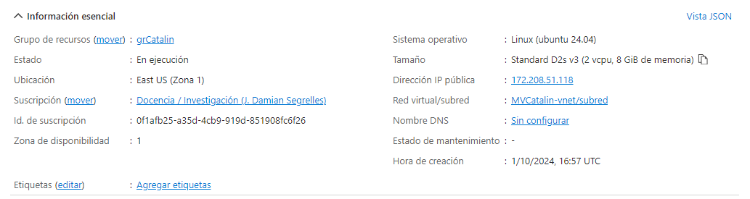

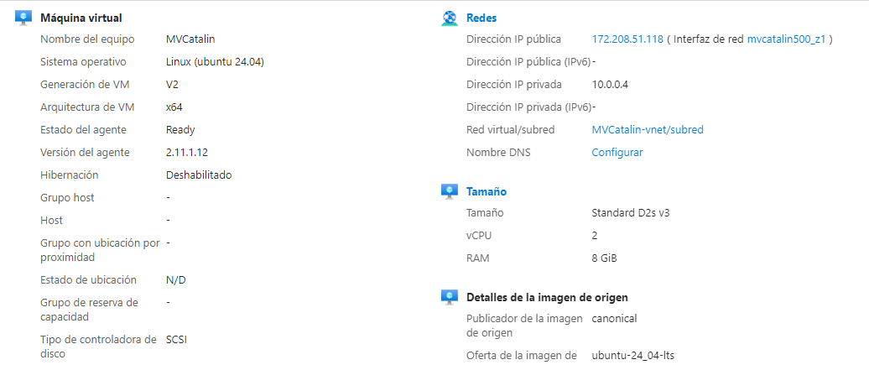

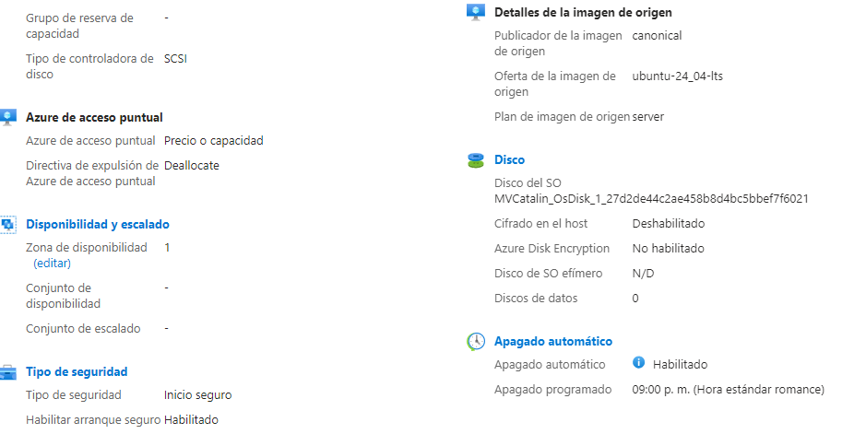

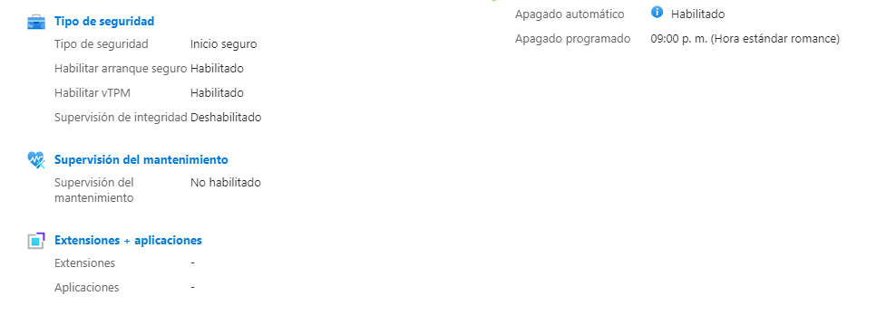

## P2. Conectarse a las MVs

Acceso MV con contraseña

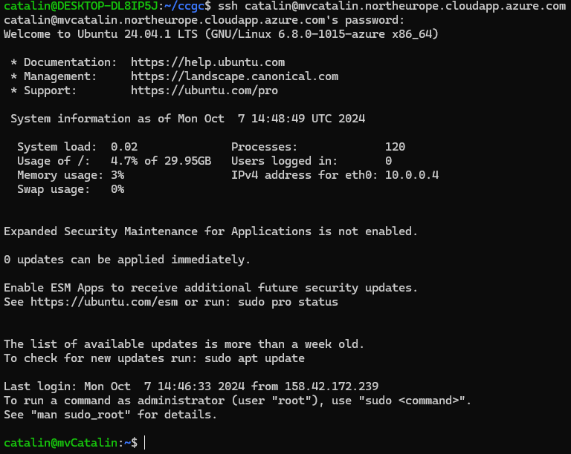

Acceso ssh:

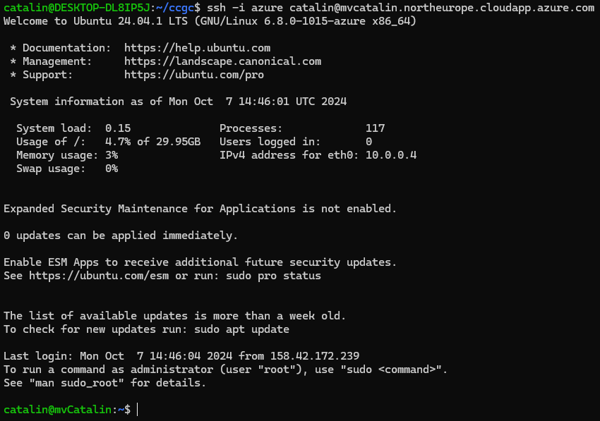

Clave pública:

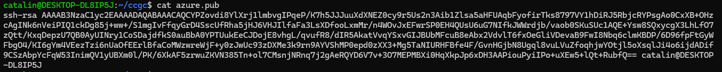

Clave privada:

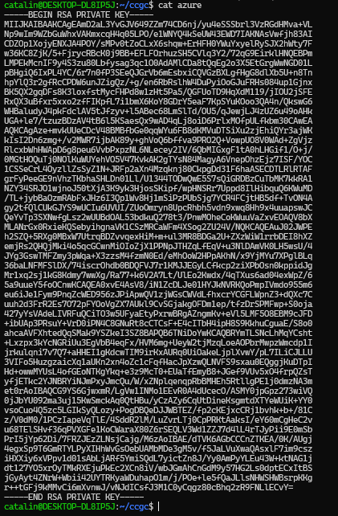

## P3. Crear un Servidor Web (Linux)

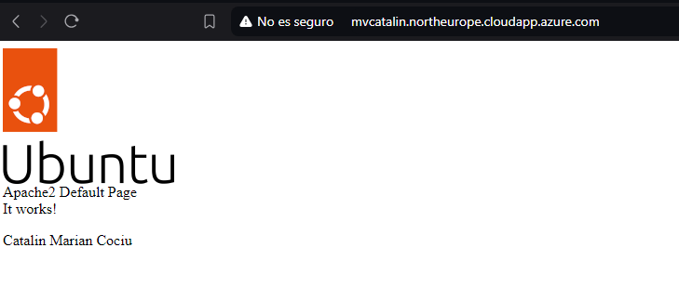

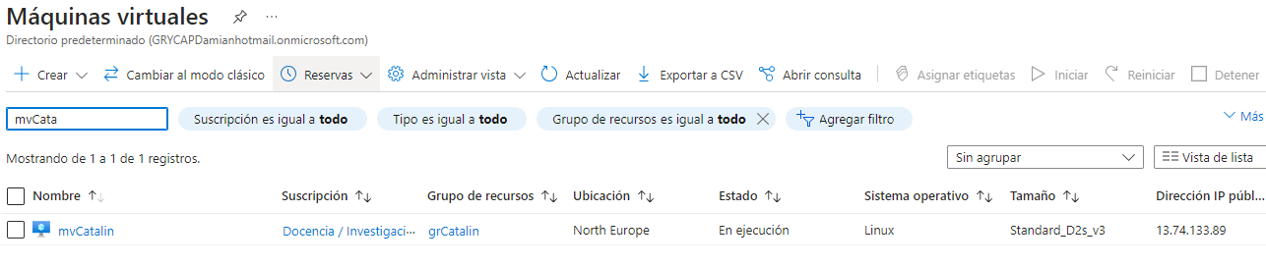

## P4. Crear un Servidor Web (Windows)

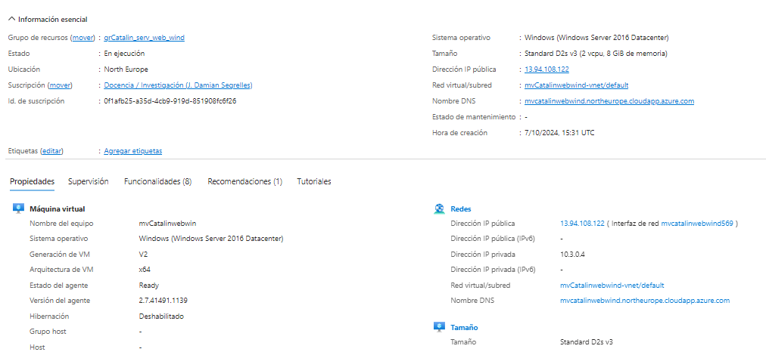

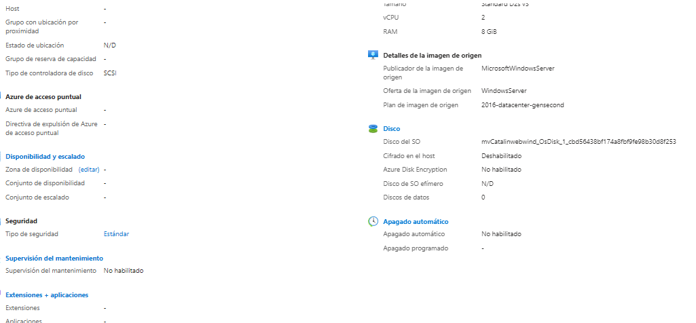

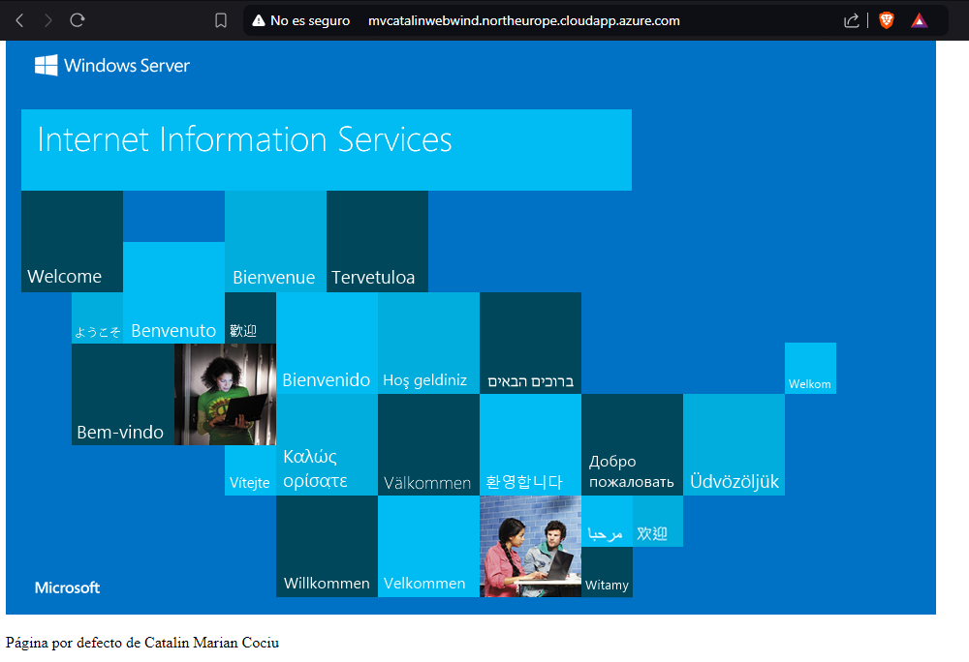

## P5. Gestión de Plantillas

MV:

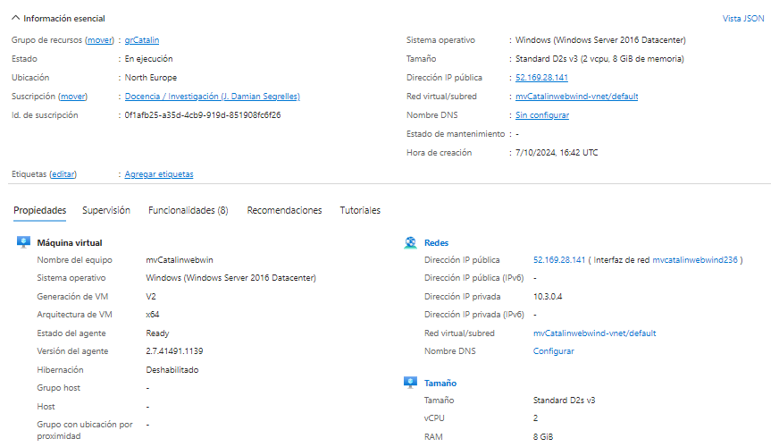

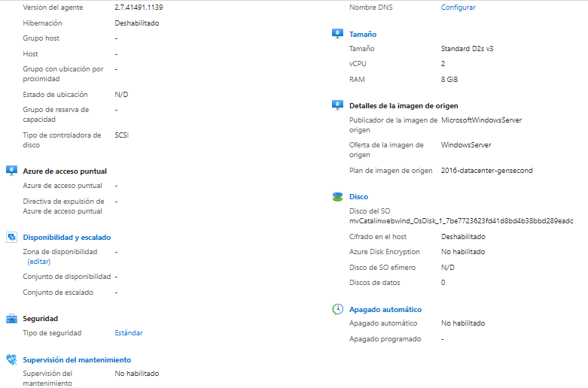

Template:

{

*"$schema"*: "http://schema.management.azure.com/schemas/2015-01-01/deploymentTemplate.json#",

*"contentVersion"*: "1.0.0.0",

*"parameters"*: {

*"location"*: {

*"type"*: "string"

},

*"networkInterfaceName"*: {

*"type"*: "string"

},

*"networkSecurityGroupName"*: {

*"type"*: "string"

},

*"networkSecurityGroupRules"*: {

*"type"*: "array"

},

*"subnetName"*: {

*"type"*: "string"

},

*"virtualNetworkName"*: {

*"type"*: "string"

},

*"addressPrefixes"*: {

*"type"*: "array"

},

*"subnets"*: {

*"type"*: "array"

},

*"publicIpAddressName"*: {

*"type"*: "string"

},

*"publicIpAddressType"*: {

*"type"*: "string"

},

*"publicIpAddressSku"*: {

*"type"*: "string"

},

*"pipDeleteOption"*: {

*"type"*: "string"

},

*"virtualMachineName"*: {

*"type"*: "string"

},

*"virtualMachineComputerName"*: {

*"type"*: "string"

},

*"virtualMachineRG"*: {

*"type"*: "string"

},

*"osDiskType"*: {

*"type"*: "string"

},

*"osDiskDeleteOption"*: {

*"type"*: "string"

},

*"virtualMachineSize"*: {

*"type"*: "string"

},

*"nicDeleteOption"*: {

*"type"*: "string"

},

*"hibernationEnabled"*: {

*"type"*: "bool"

},

*"adminUsername"*: {

*"type"*: "string"

},

*"adminPassword"*: {

*"type"*: "secureString"

},

*"patchMode"*: {

*"type"*: "string"

},

*"enableHotpatching"*: {

*"type"*: "bool"

}

},

*"variables"*: {

*"nsgId"*: "[resourceId(resourceGroup().name, 'Microsoft.Network/networkSecurityGroups', parameters('networkSecurityGroupName'))]",

*"vnetName"*: "[parameters('virtualNetworkName')]",

*"vnetId"*: "[resourceId(resourceGroup().name,'Microsoft.Network/virtualNetworks', parameters('virtualNetworkName'))]",

*"subnetRef"*: "[concat(variables('vnetId'), '/subnets/', parameters('subnetName'))]"

},

*"resources"*: [

{

*"name"*: "[parameters('networkInterfaceName')]",

*"type"*: "Microsoft.Network/networkInterfaces",

*"apiVersion"*: "2022-11-01",

*"location"*: "[parameters('location')]",

*"dependsOn"*: [

"[concat('Microsoft.Network/networkSecurityGroups/', parameters('networkSecurityGroupName'))]",

"[concat('Microsoft.Network/virtualNetworks/', parameters('virtualNetworkName'))]",

"[concat('Microsoft.Network/publicIpAddresses/', parameters('publicIpAddressName'))]"

],

*"properties"*: {

*"ipConfigurations"*: [

{

*"name"*: "ipconfig1",

*"properties"*: {

*"subnet"*: {

*"id"*: "[variables('subnetRef')]"

},

*"privateIPAllocationMethod"*: "Dynamic",

*"publicIpAddress"*: {

*"id"*: "[resourceId(resourceGroup().name, 'Microsoft.Network/publicIpAddresses', parameters('publicIpAddressName'))]",

*"properties"*: {

*"deleteOption"*: "[parameters('pipDeleteOption')]"

}

}

}

}

],

*"networkSecurityGroup"*: {

*"id"*: "[variables('nsgId')]"

}

}

},

{

*"name"*: "[parameters('networkSecurityGroupName')]",

*"type"*: "Microsoft.Network/networkSecurityGroups",

*"apiVersion"*: "2020-05-01",

*"location"*: "[parameters('location')]",

*"properties"*: {

*"securityRules"*: "[parameters('networkSecurityGroupRules')]"

}

},

{

*"name"*: "[parameters('virtualNetworkName')]",

*"type"*: "Microsoft.Network/virtualNetworks",

*"apiVersion"*: "2024-01-01",

*"location"*: "[parameters('location')]",

*"properties"*: {

*"addressSpace"*: {

*"addressPrefixes"*: "[parameters('addressPrefixes')]"

},

*"subnets"*: "[parameters('subnets')]"

}

},

{

*"name"*: "[parameters('publicIpAddressName')]",

*"type"*: "Microsoft.Network/publicIpAddresses",

*"apiVersion"*: "2020-08-01",

*"location"*: "[parameters('location')]",

*"properties"*: {

*"publicIpAllocationMethod"*: "[parameters('publicIpAddressType')]"

},

*"sku"*: {

*"name"*: "[parameters('publicIpAddressSku')]"

}

},

{

*"name"*: "[parameters('virtualMachineName')]",

*"type"*: "Microsoft.Compute/virtualMachines",

*"apiVersion"*: "2024-03-01",

*"location"*: "[parameters('location')]",

*"dependsOn"*: [

"[concat('Microsoft.Network/networkInterfaces/', parameters('networkInterfaceName'))]"

],

*"properties"*: {

*"hardwareProfile"*: {

*"vmSize"*: "[parameters('virtualMachineSize')]"

},

*"storageProfile"*: {

*"osDisk"*: {

*"createOption"*: "fromImage",

*"managedDisk"*: {

*"storageAccountType"*: "[parameters('osDiskType')]"

},

*"deleteOption"*: "[parameters('osDiskDeleteOption')]"

},

*"imageReference"*: {

*"publisher"*: "MicrosoftWindowsServer",

*"offer"*: "WindowsServer",

*"sku"*: "2016-datacenter-gensecond",

*"version"*: "latest"

}

},

*"networkProfile"*: {

*"networkInterfaces"*: [

{

*"id"*: "[resourceId('Microsoft.Network/networkInterfaces', parameters('networkInterfaceName'))]",

*"properties"*: {

*"deleteOption"*: "[parameters('nicDeleteOption')]"

}

}

]

},

*"securityProfile"*: {},

*"additionalCapabilities"*: {

*"hibernationEnabled"*: false

},

*"osProfile"*: {

*"computerName"*: "[parameters('virtualMachineComputerName')]",

*"adminUsername"*: "[parameters('adminUsername')]",

*"adminPassword"*: "[parameters('adminPassword')]",

*"windowsConfiguration"*: {

*"enableAutomaticUpdates"*: true,

*"provisionVmAgent"*: true,

*"patchSettings"*: {

*"enableHotpatching"*: "[parameters('enableHotpatching')]",

*"patchMode"*: "[parameters('patchMode')]"

}

}

}

}

}

],

*"outputs"*: {

*"adminUsername"*: {

*"type"*: "string",

*"value"*: "[parameters('adminUsername')]"

}

}

}

Parameters:

{

*"$schema"*: "https://schema.management.azure.com/schemas/2015-01-01/deploymentParameters.json#",

*"contentVersion"*: "1.0.0.0",

*"parameters"*: {

*"location"*: {

*"value"*: "northeurope"

},

*"networkInterfaceName"*: {

*"value"*: "mvcatalinwebwind236"

},

*"networkSecurityGroupName"*: {

*"value"*: "mvCatalinwebwind-nsg"

},

*"networkSecurityGroupRules"*: {

*"value"*: [

{

*"name"*: "RDP",

*"properties"*: {

*"priority"*: 300,

*"protocol"*: "TCP",

*"access"*: "Allow",

*"direction"*: "Inbound",

*"sourceAddressPrefix"*: "*",

*"sourcePortRange"*: "*",

*"destinationAddressPrefix"*: "*",

*"destinationPortRange"*: "3389"

}

},

{

*"name"*: "HTTP",

*"properties"*: {

*"priority"*: 320,

*"protocol"*: "TCP",

*"access"*: "Allow",

*"direction"*: "Inbound",

*"sourceAddressPrefix"*: "*",

*"sourcePortRange"*: "*",

*"destinationAddressPrefix"*: "*",

*"destinationPortRange"*: "80"

}

}

]

},

*"subnetName"*: {

*"value"*: "default"

},

*"virtualNetworkName"*: {

*"value"*: "mvCatalinwebwind-vnet"

},

*"addressPrefixes"*: {

*"value"*: [

"10.3.0.0/16"

]

},

*"subnets"*: {

*"value"*: [

{

*"name"*: "default",

*"properties"*: {

*"addressPrefix"*: "10.3.0.0/24"

}

}

]

},

*"publicIpAddressName"*: {

*"value"*: "mvCatalinwebwind-ip"

},

*"publicIpAddressType"*: {

*"value"*: "Static"

},

*"publicIpAddressSku"*: {

*"value"*: "Standard"

},

*"pipDeleteOption"*: {

*"value"*: "Detach"

},

*"virtualMachineName"*: {

*"value"*: "mvCatalinwebwind"

},

*"virtualMachineComputerName"*: {

*"value"*: "mvCatalinwebwin"

},

*"virtualMachineRG"*: {

*"value"*: "grCatalin_serv_web_wind"

},

*"osDiskType"*: {

*"value"*: "Standard_LRS"

},

*"osDiskDeleteOption"*: {

*"value"*: "Delete"

},

*"virtualMachineSize"*: {

*"value"*: "Standard_D2s_v3"

},

*"nicDeleteOption"*: {

*"value"*: "Detach"

},

*"hibernationEnabled"*: {

*"value"*: false

},

*"adminUsername"*: {

*"value"*: "catalin"

},

*"adminPassword"*: {

*"value"*: null

},

*"patchMode"*: {

*"value"*: "AutomaticByOS"

},

*"enableHotpatching"*: {

*"value"*: false

}

}

}

## P6. Crear una Imagen desde una MV

MV linux original:

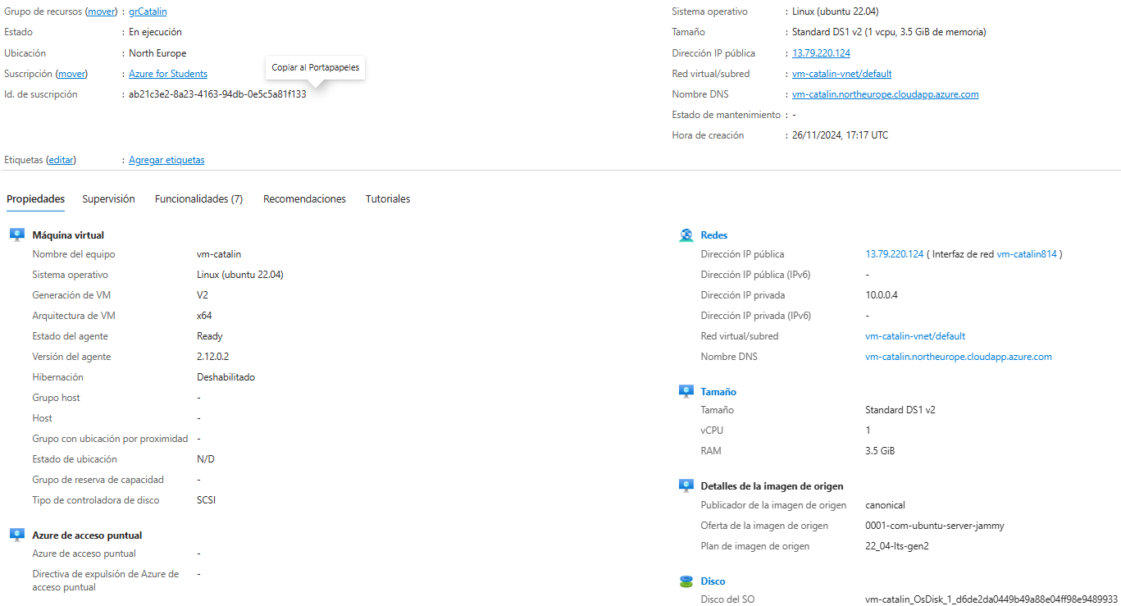

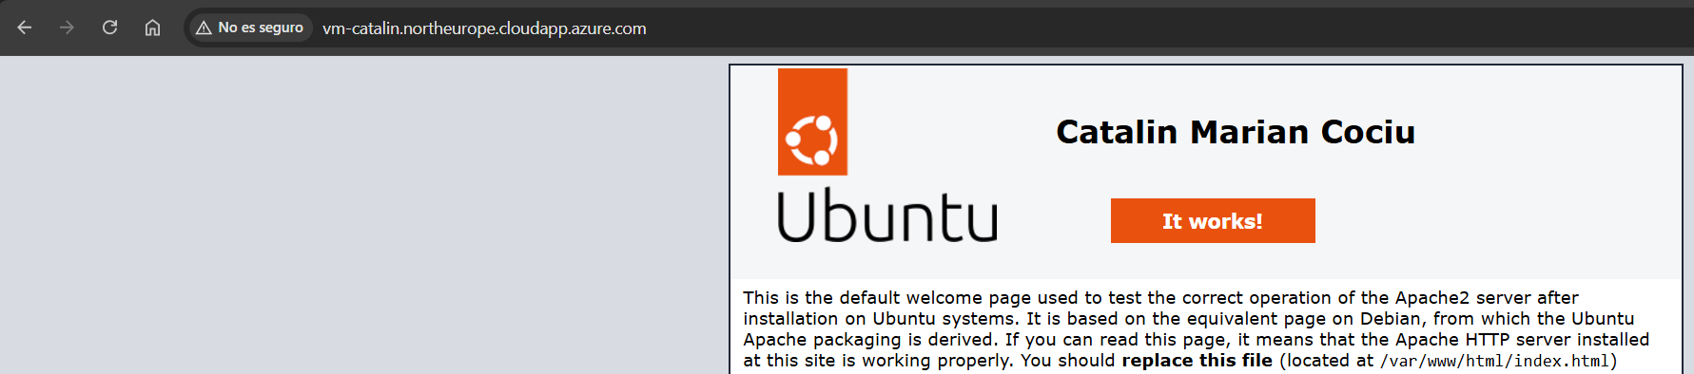

MV a partir de imagen:

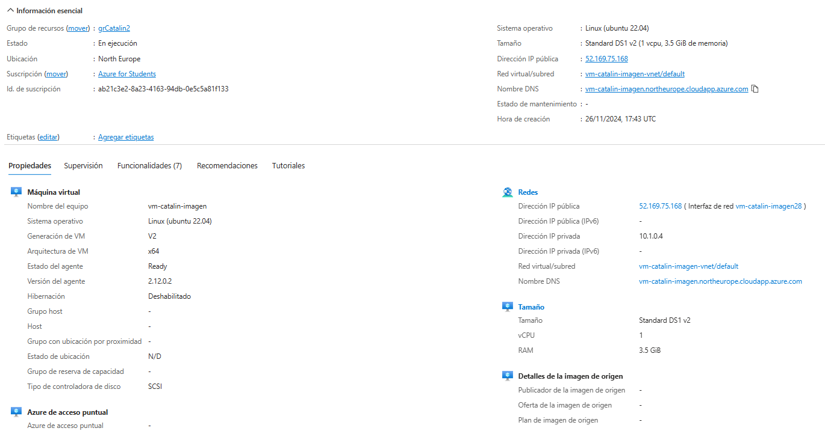

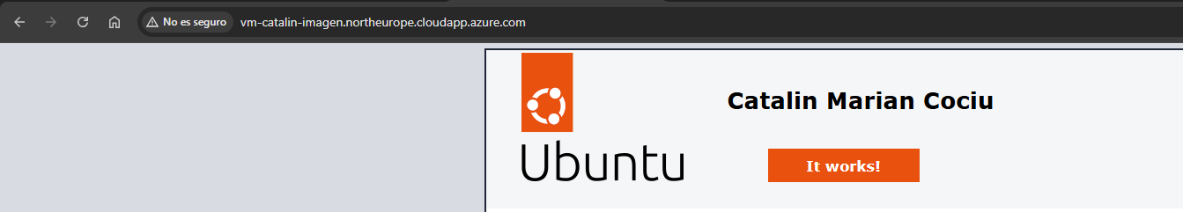

## P7. Clúster MPI en Azure

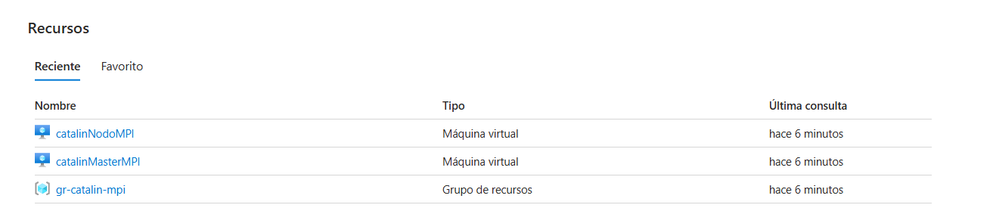

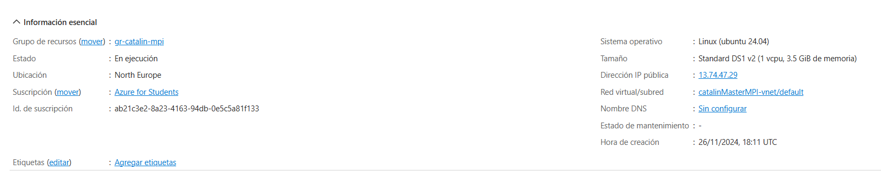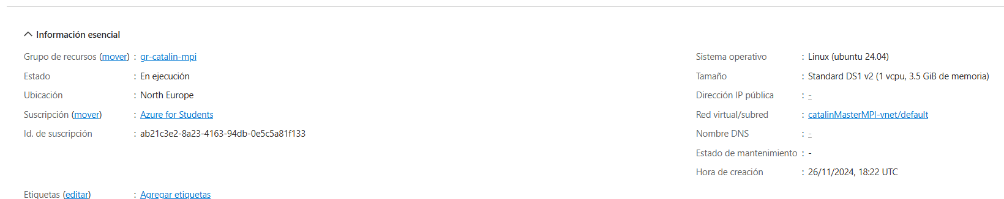

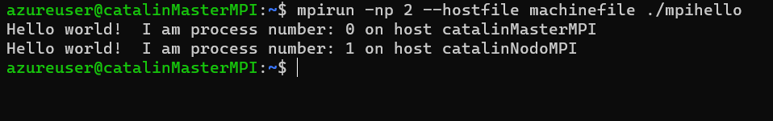

## P8. Benchmarking

MV B4ms

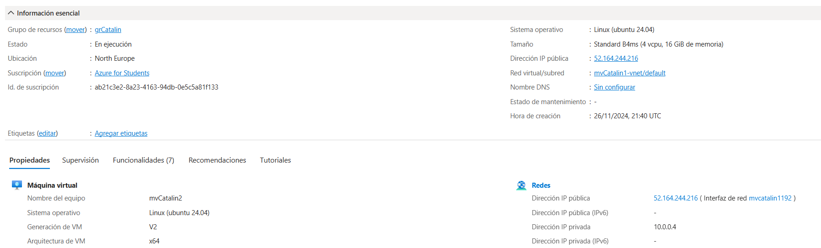

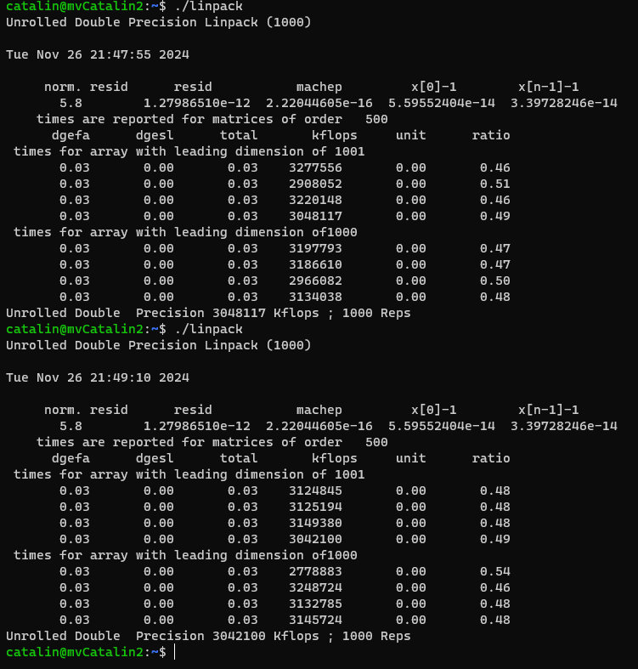

B4ms => Media de tiempos: 0.03s

MV D2s v3

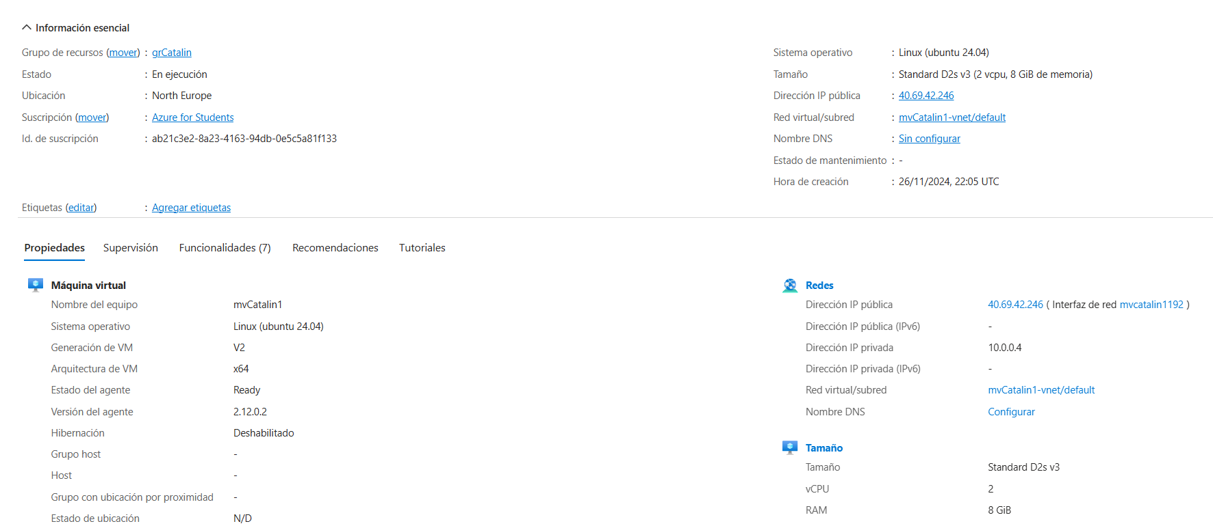

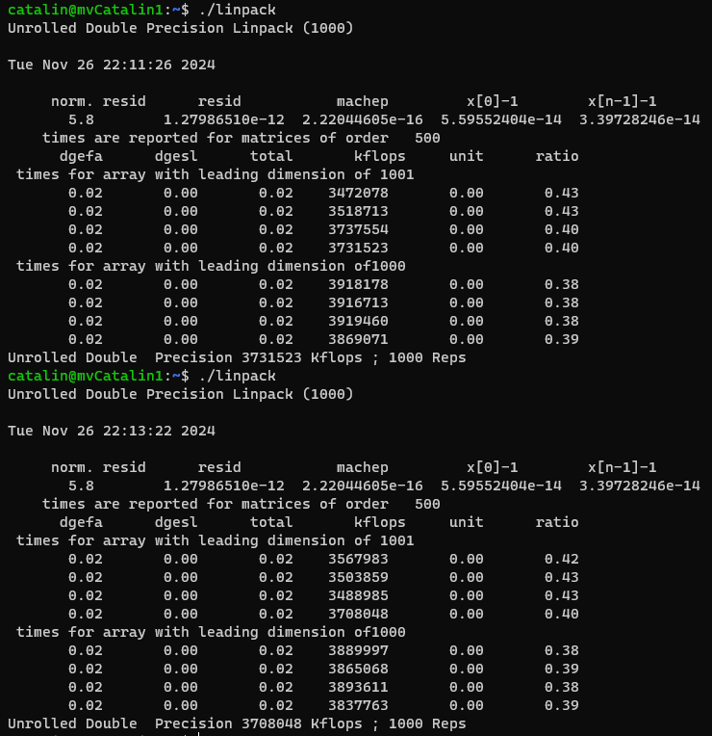

D2s_v3 => media: 0.02s